|  |  |  |  |  |  |
| --- | --- | --- | --- | --- | --- |
| **Qualification** | **BTEC Level 5 HND Diploma in Computing** | | | | |
| **Unit number and title** | Unit 2: Networking Infrastructure | | | | |
| **Submission date** |  | **Date Received 1st submission** | |  | |
| **Re-submission Date** |  | **Date Received 2nd submission** | |  | |
| **Student Name** | Bùi Hương Linh | **Student ID** | | GBH200662 | |
| **Class** | GCH1002 | **Assessor name** | | Omar | |
| **Student declaration**  I certify that the assignment submission is entirely my own work and I fully understand the consequences of plagiarism. I understand that making a false declaration is a form of malpractice. | | | | | |
|  |  | | **Student’s signature** | |  |

**Grading grid**

|  |  |  |  |  |  |  |
| --- | --- | --- | --- | --- | --- | --- |
| P1 | P2 | P3 | P4 | M1 | M2 | D1 |
|  |  |  |  |  |  |  |

Table of Contents

Task 1: The benefits and constraints of different network types and standards (P1) 3

I/ Introduction: 3

II/ Network Definition: 3

III/ Role of Network 3

IV/ Network Types and Protocols 4

IV.1/ Types of Network 4

IV.2/ Protocols and Standards 7

Task 2: Network topology & communication and Bandwidth requirements 8

I/ Network Topology 8

I.1/ Physical Topology 8

I.2/ Logical Topology 12

II/ Communication and Bandwidth 13

II.1/ Rules of communication 13

II.2/ Bandwidth 15

Task 3: Networking Devices and Server Types 16

I/ Networking Devices 16

II/ Server types 20

Task 4: Inter-dependence of workstation hardware with relevant networking software 21

I/ Workstation hardware Definition 21

II/ Networking Software definition 22

III/ Interdependence of workstation hardware with networking software 22

Task 5: Conclution 22

Bibliography 23

# Task 1: The benefits and constraints of different network types and standards (P1)

## I/ Introduction:

In work and life, we cannot lack relationships to support each other. Especially for those who work in the service sector such as the restaurant - hotel industry, relationship building skills are extremely important. Because that will be the network of potential customers or partners. Therefore, the networking is very important for humans.(source: Internet)

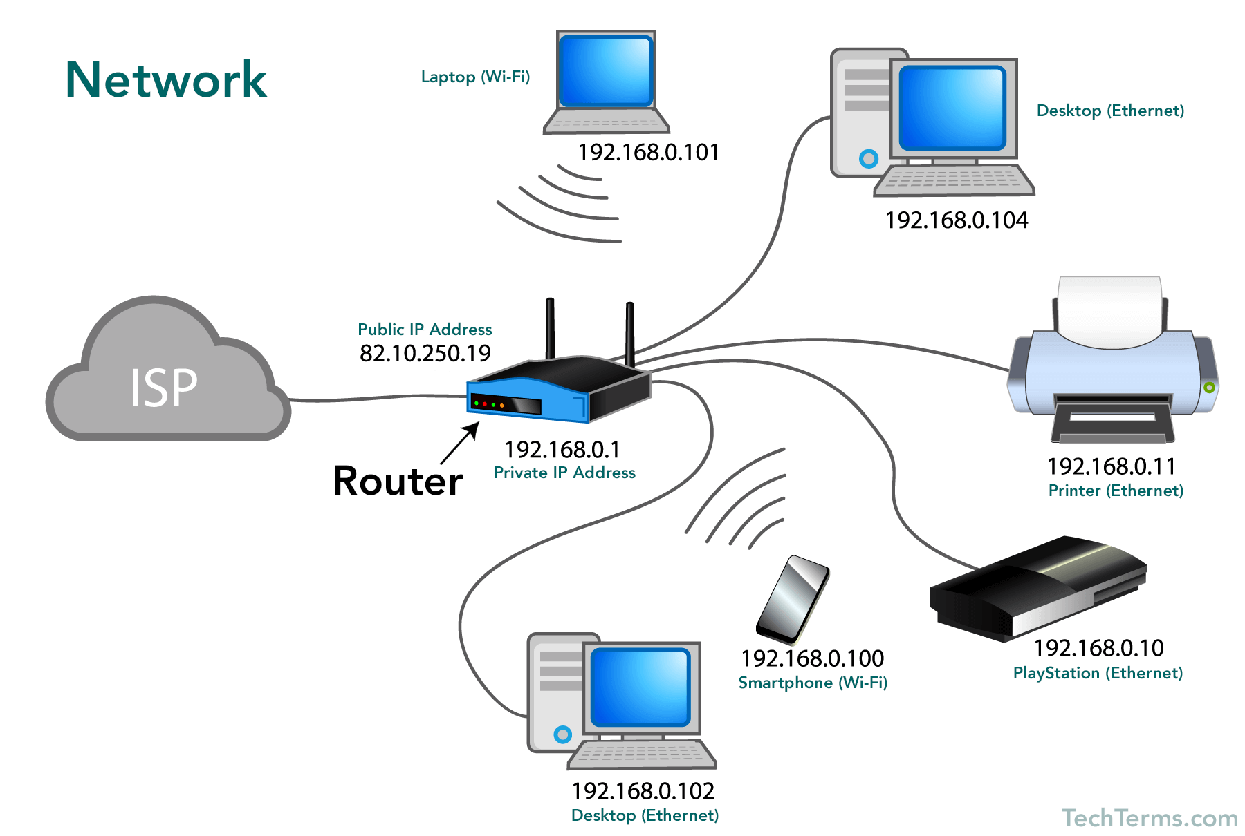

Image 1: Network (source: Internet)

## II/ Network Definition:

A network consists of two or more computers connected together, and they can communicate, exchange and share resources. E.g: information, sharing files…. ( University of South Florida, 2013)

## III/ Role of Network

* Advantages of a network:

+ Sharing data and information

+ Hardware sharing

+ Software sharing

+ Communication

* Disadvantages of a network:

+ Viruses and Malware

## IV/ Network Types and Protocols

### IV.1/ Types of Network

1. LAN

* A local area network (LAN) is a network that is confined to a small geographical area such as a school or building. computers and devices are connected to each other by a wireless connection or a wired connection.( University of South Florida, 2013)

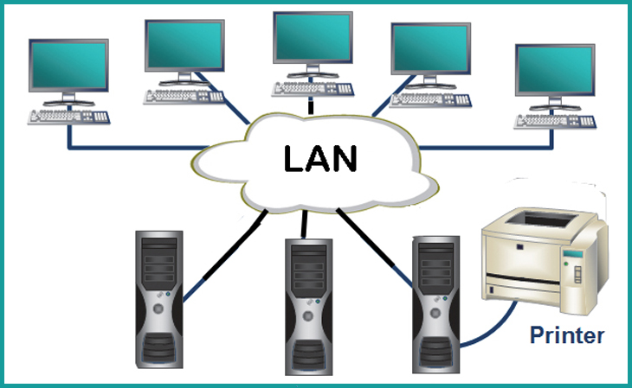

Image 2: LAN(source: Internet)

* **Advantages of a LAN:**

**+ Data sharing**

**+ Software sharing**

**+ Very fast and reliable data transfer**

**+ Convenient communication**

* Disadvantages of a LAN:

+ Slow speed

+ Covering a certain distance

+ Often have network problems

1. WAN

* A wide area network (WAN) is a combination of a LAN and a MAN network connected via satellite, fiber optic cable or wire cable. This wide area network can both connect to a private network and create connections large, covering an entire country or globally. .

( University of South Florida, 2013)

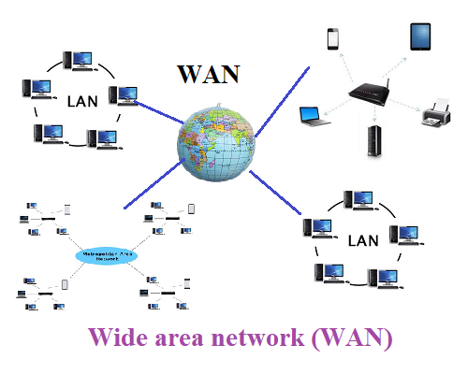

Image 3: WAN(source: Internet)

* Advantages of a WAN:

+ Extensive connectivity

+ Easily share information

+ No signal limitation

+ Good security

* Disadvantages of a WAN:

+ The setup cost is high

+ Troubleshooting problems

+ Maintenance issues

+ Needs firewall and antivirus software

1. MAN

* Metropolitan area network (MAN) is connected from many LANs via cables, other means of communication, etc., capable of connecting in large areas such as provinces, districts and cities. MAN network is often used mainly for objects such as organizations, factories,… MAN is larger than LAN and smaller than WAN. (Arsal Jahejo, 2021)

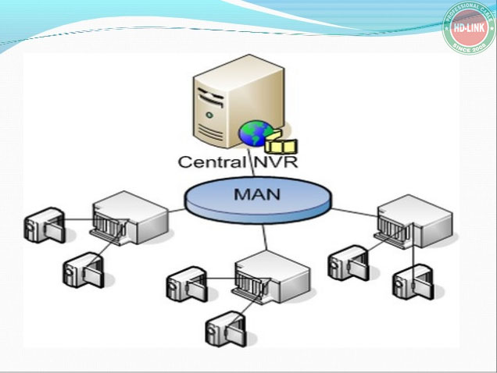

Image 4: MAN(source: Internet)

* Advantages of a MAN:

+ Less expensive

+ High security: a high-security level than WAN

+ Conversion of LAN to MAN is easy

+ Sharing of the internet

+ High speed than WAN

* Disadvantages of a MAN:

+ Diffcult to manage

+ High cost

### IV.2/ Protocols and Standards

1. Network Protocols Definition

* Protocols define the format, order of messages sent and received among network entities, and actions taken on msg transmission, receipt. (pp,lecture 1)

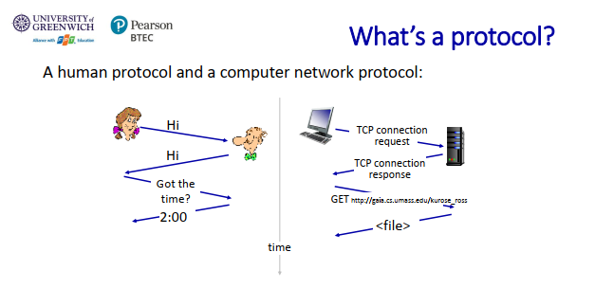

Image 5: Network protocols(source: pp, lecture 1)

1. List some protocols: TCP/IP, HTTP, DNS, ICMP,..

* TCP/IP: Transmission Control Protocol/Internet Protocol(tcp/ip) is a set of information exchange protocols used to connect network devices on the Internet. TCP/IP can be used as an information exchange protocol in a private network. (Justin Stoltzfus,2021)
* HTTP: Hyper Text Transfer Protocol (HTTP) is a set of rules for transmitting data such as images, audio, text, video, etc. over the web. HTTP is the essential means of communication between web users and the server that maintains the website.

(Wesley Chai, 2021)

* DNS: Domain Name System is a system that allows setting correspondence between IP addresses and domain names on the Internet. DNS is also the key to many network services such as internet browsing, mail server, web server, ….

(Copyright by Fortinet, 2021)

1. List some standard organizations and standard’s name.

* Institute of Electronics and Electrical Engineers (IEEE)
* International Telecommunication Union (ITU)
* International Organization for Standardization (ISO)
* American National Standards Institute (ANSI)
* International Electrotechnical Commission (IEC)

………………………………

(Karen Bartleson, 2021)

# Task 2: Network topology & communication and Bandwidth requirements

## I/ Network Topology

### I.1/ Physical Topology

- Definition: A physical topology is how they are actually interconnected with wires and cables.

( Engr Fahad, 2021)

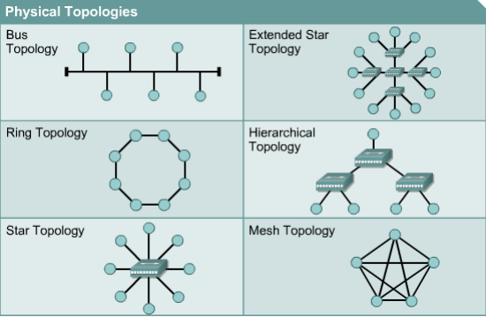

Image 6: Physical Topology (source: Internet)

1. Mesh ( Engr Fahad, 2021)

* Routers are interconnected with other routers, with at least two pathways connecting each router. Mesh is a common application in networks that play an important role and cannot be discontinued.

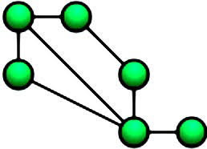

Image 7 : Mesh (source: Internet)

* Advantages:

+ Advantage of privacy or security

+ Point-to-point links make fault identification and fault isolation easy

* Disadvantages:

+ Required high amount of cabling and the number of I/O ports

+ The hardware required to connect each link can be prohibitively expensive.

1. Star ( Engr Fahad, 2021)

* All node on the network is connected through a central device.

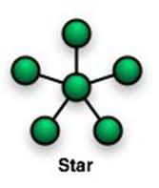

Image 8 : Star (source: Internet)

* Advanyages:

+ Easy for Fault identification and fault isolation

+ Less Expensive than Mesh topology

+ Less cabling

* Disadvantages:

+ The dependency of the whole topology on one single point, the hub. If the hub crashes, the whole system will stop working.

1. Bus ( Engr Fahad, 2021)

* Bus is a single cable that is used to connect all the nodes in this topology without intervening connecting devices.

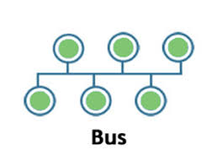

Image 9 : Bus (source: Internet)

* Advantages:

+ Easy to install

+ Costs low

+ Easy to add systems to network

+ Great for small networks

+ Easy to implement

* Disadvantages:

+ Out of date technology.

+ Include difficult reconnection and fault isolation

+ Difficult to troubleshoot.

+ Unmanageable in a large network

+ If cable breaks, whole network is down

1. Ring ( Engr Fahad, 2021)

* Each node is connected to the two nearest nodes so the entire network forms a circle.

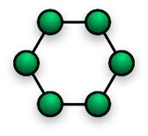

Image 10 : Ring (source: Internet)

* Advantages:

+ Performs better than a bus topology under heavy network load

+ Does not require network server to manage the connectivity between the computers

* Disadvantages:

+ Moves, adds and changes of devices can affect the network

+ Much slower than an Ethernet network

+ Expensive

1. Tree ( Engr Fahad, 2021)

* There is a root node in this topology and all other nodes are connected through the root node.

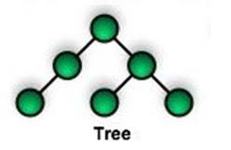

Image 11 : Tree (source: Internet)

* Advantages:

+ Accessibility for troubleshooting

+ Centralized device management -> increased system security

* Disadvantages:

+ Expensive due to the use of many concentrators

### I.2/ Logical Topology

* Definition: A logical topology is how devices appear connected to the user.
* Logical Bus – The data follows a linear pattern from the source to all destinations.
* Logical Ring – In this topology, the data travels in the form of a ring from a device to another and reaches to the beginning of the circle.

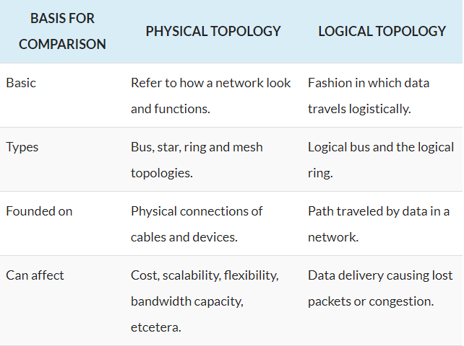

Image 12 : Comparison Chart (source: Internet)

## II/ Communication and Bandwidth

### II.1/ Rules of communication

* Definition: A network communication is a set of protocols that allow application programs to communicate with each other without the need for hardware and an operating system. (Copyright ArcGIS Pro, 2021)
* The rules in the network: (Copyright ArcGIS Pro, 2021)

+ Junction-edge connectivity: governs the types of intersection features that can be connected to edge features. This rule builds on existing feature constraints for geometric coincidences and valid connection.

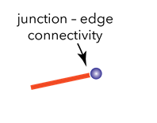

Image 13 : Junction-edge connectivity (source: Internet)

+ Junction-junction connectivity: govern the establishment of a connectivity association between two point features that are not necessarily geometrically coincident or between two junction objects.

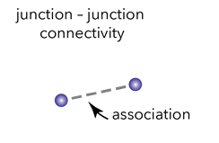

Image 14 : Junction-junction connectivity (source: Internet)

+ Edge-junction-edge connectivity: supports connecting line terminals to a device or object that is intersecting terminals.

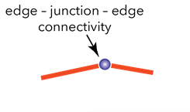

Image 15: Edge-junction-edge connectivity (source: Internet)

### II.2/ Bandwidth

* Definition: Bandwidth is the maximum data transfer rate over a given path and is an important factor when determining the quality, speed of a network, or an Internet connection. ( Copyright Paessler AG, 2021)

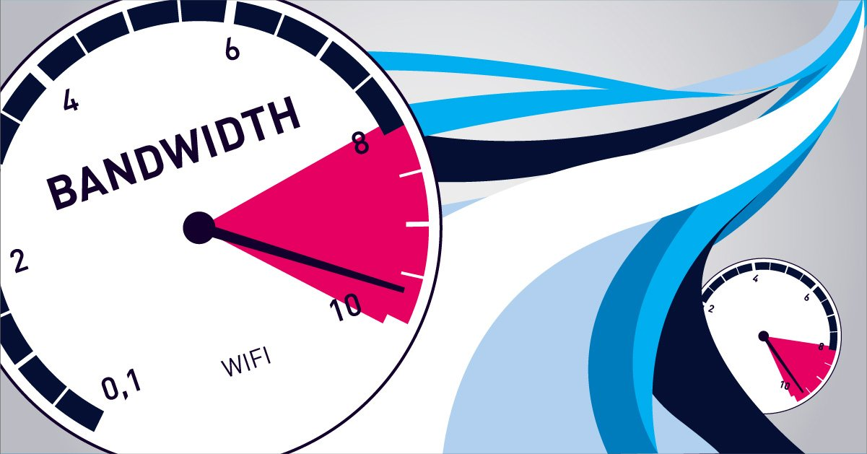

Image 16 : Bandwidth (source: Internet)

* Bandwidth is measured in bits per second (bps). However, over time, the bandwidth is getting bigger and bigger, so the units used to measure it are also higher, such as Megabit/s (Mbps), Gigabit/s (Gbps), Terabit/s (Tbps). ( Copyright Paessler AG, 2021)

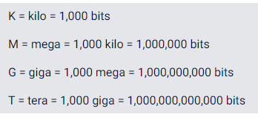

Image 17: Unit conversion(source: Internet)

* A higher bandwidth allows you to use to upload and download larger amounts of data to your site. Faster data transmission speed. A higher bandwidth results in faster transfer speeds results in no frustration and greater customer satisfaction.

( Copyright Paessler AG, 2021)

* As technology is developing day by day. Users Demand for high speed internet, so to provide the highest data speed, higher bandwidth is required. ( Copyright Paessler AG, 2021)

# Task 3: Networking Devices and Server Types

## I/ Networking Devices

* Definition: Network devices are the physical devices needed to communicate and interact between the hardware on a computer network. (Jeff Melnick, 2021)

+ The list of common networking devices: Bridge, switch, router, modem, hub, gateway,…

* Switches: ( Priya Pedamkar, 2021)

+ A switch is a multiport bridge with a buffer and a design that can boost its efficiency and performance.

+ The switch is designed in such a way that it can boost its productivity.

+ It is designed with a buffer.

+ It is a multi-port bridge device.

+ It forwards data, but before doing that, it checks errors. This makes it more efficient and improves its performance, as it forwards the good and efficient packet to the correct port only, which doesn’t have errors.

+ It simply is a better version of a hub. As with a hub, with a switch also, the computer device is connected through one line, but the switch works smartly about where it sends the data that is coming through one of its ports.

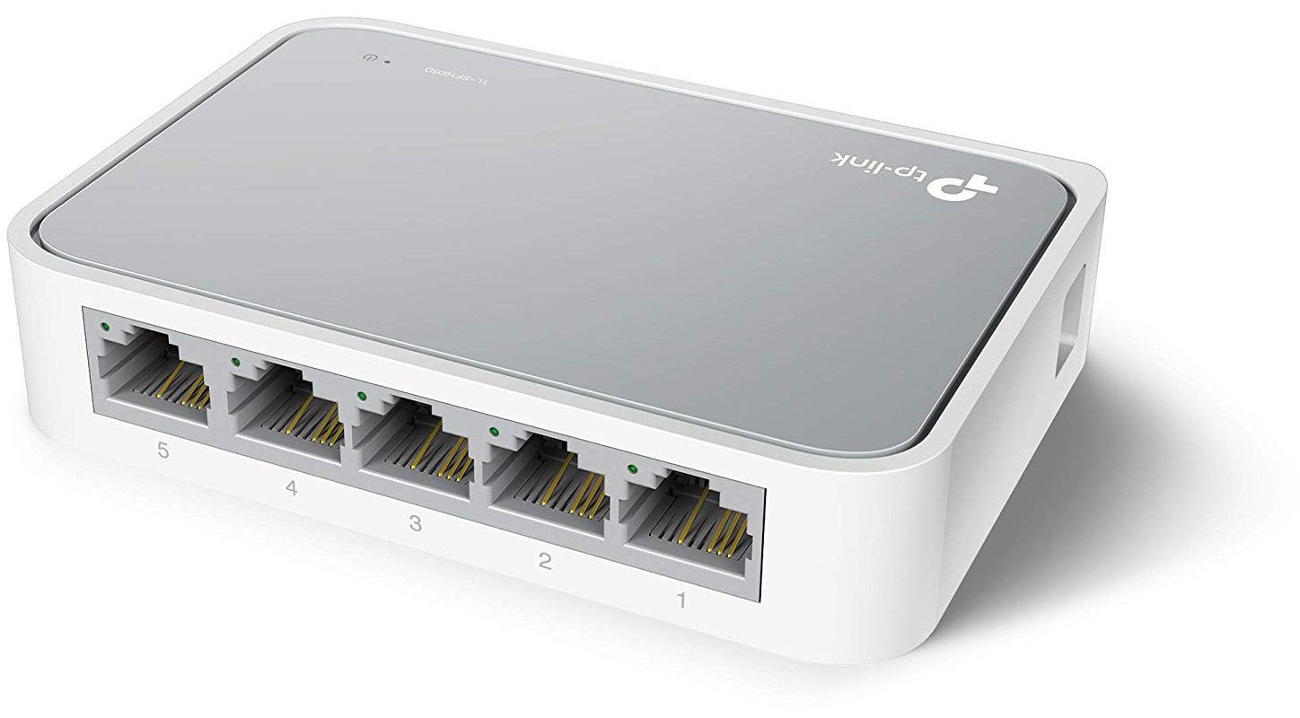

Image 18: Switches (source: Internet)

* Routers: ( Priya Pedamkar, 2021)

+ A router is a device like a switch that routes data packets based on their IP addresses.

+ The IP address would be used in the case of TCP/IP networks. They play a major role in a large TCP/IP network. And in reality, TCP/IP routing protocols and network routers have helped the Internet to become as huge as it is today. They control traffic and keep the network productive.

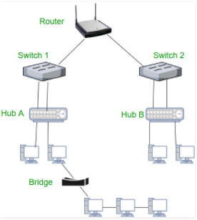

Image 19: Router (source: Internet)

* Firewall: (Migelle, 2021)

+ Firewall is a network security device that monitors incoming and outgoing traffic and filters traffic from suspicious or unsecured sources.

+ Firewalls examine and monitor incoming and outgoing packets, and block those that do not meet the specified security criteria.

+ Firewalls basically block suspicious traffic like viruses and hackers.

+ Firewall can be categorized as packet filters, circuit-level gateways, application gateways and stateful inspection firewall.

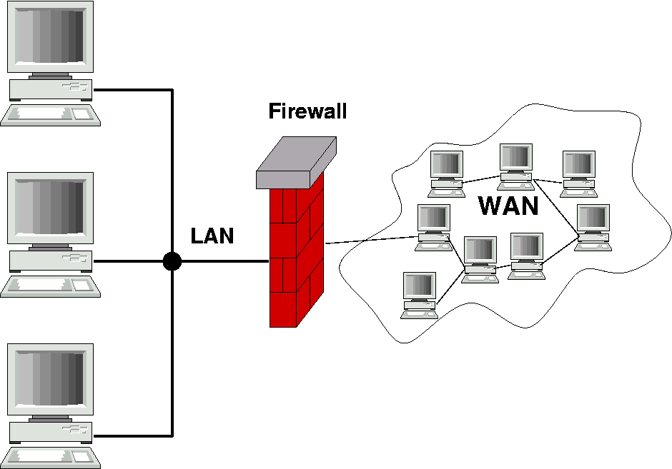

Image 20: Firewall(source: Internet)

* Gateway: (Migelle, 2021)

+ Definition: A gateway is a network hardware device or hardware node that is used to connect two different networks together.

+ Two major functions: to connect different devices with one another and to connect devices to public and private networks.

+ Allow two disparate network systems to communicate with each other.

+ Most common gateways are computer and router connecting an enterprise to a network.

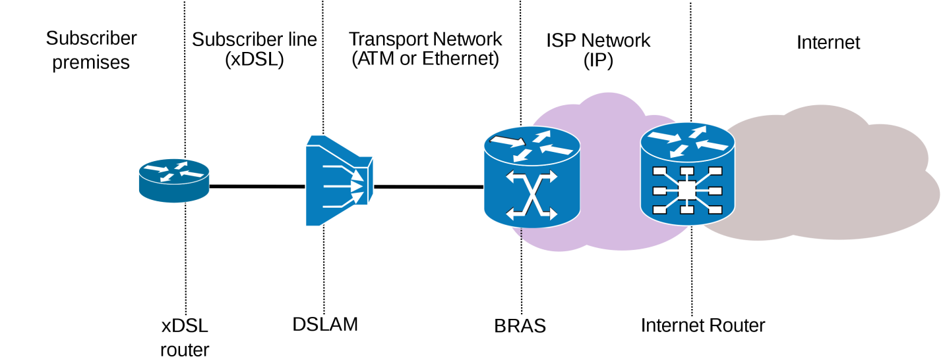

Image 21: Gateway (source: Internet)

## II/ Server types

* DHCP server

+ A DHCP Server is a network server that automatically provides and assigns IP addresses, default gateways and other network parameters to client devices. DHCP is responsible for fast, automatic and centralized management of IP address distribution within a network. In addition, DHCP also helps to bring information to more reasonable devices as well as configure subnet mask or default gateway.( CopyRight Infoblox, 2021)

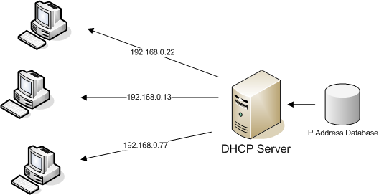

Image 22: DHCP Server (source: Internet)

* DNS server

+ Domain Name System is an ordinal naming system for computers and services participating in the Internet. It associates a variety of information with the domain names assigned to them so that users can use that domain to find out the information they need to know. It is important to choose a domain name that makes sense to the user, which is linked to other network devices to locate and provide information to users around the world.( Kuntal Chakraborty, 2021)

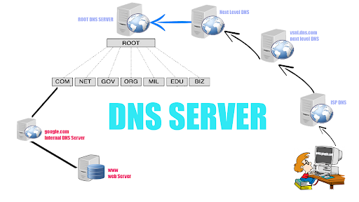

Image 23: DNS Server (source: Internet)

# Task 4: Inter-dependence of workstation hardware with relevant networking software

## I/ Workstation hardware Definition

* A workstation (WS) is a computer dedicated to a user or group of users engaged in business or professional work. It includes one or more high resolution displays and a faster processor than a personal computer (PC). (Techopedia, 2021)
* For example: A "workstation" may be an average-powered computer connected to a larger network. It can also refer to a powerful computer intended for serious academic or professional computation.( Computer Hope, 2021)

## II/ Networking Software definition

* Networking software is a foundational element for any network. It is an extremely broad term for a range of software aimed at the design and implementation of modern networks. It helps administrators deploy, manage, and monitor a network. Network software allows multiple devices, such as desktops, laptops, mobile phones, tablets, and other systems to connect to one another. (SDxCentral Studios, 2021)

## III/ Interdependence of workstation hardware with networking software

A work station is a computer intended for individual use that is faster and more competent than a personal computer. Because they are PCs, they may be utilized independently of the mainframe if they have their own software and hard disk storage. We'll talk about how workstation hardware and networking software are intertwined. A network interface card is a piece of computer hardware that allows computers to be linked together in a network, often a local area network. Networked computers always interact with one another using a predefined protocol for transmitting data packets. The Network Interface Card serves as a translator, allowing machines to send and receive data via a LAN. These cards are widely used by information system specialists to set up wireless or wired networks.( Cyril Muyobo, 2021)

Eg:

+ Facebook, Instagram, Zalo,… Social media is very popular for everyone nowadays.

+ You can view videos and search for music on YouTube.

+ You can use google to find the information you need.

…………………………………………………….

# Task 5: Conclution

In short, I have explained all my views about the network. A network is the connection of two or more computers. Protocols and standards make up the set of rules for computers on a network to communicate with each other. three common types of networks that I know of: WAN, MAN, LAN. I gained experience after working hard on this task which will be useful for future project.

# Bibliography

AG, P. (2021, December 7). Retrieved from paessler.com: https://www.paessler.com/it-explained/bandwidth

Bartleson, K. (2021, December 7). Retrieved from electronicdesign.com: https://www.electronicdesign.com/technologies/communications/article/21796419/10-standards-organizations-that-affect-you-whether-you-know-it-or-not

Chai, W. (2021, December 7). Retrieved from whatis.techtarget.com: https://whatis.techtarget.com/definition/HTTP-Hypertext-Transfer-Protocol

Chakraborty, K. (2021, December 8). Retrieved from techopedia.com: https://www.techopedia.com/definition/28503/dns-server

Fahad, E. (2021, December 7). Retrieved from electroniclinic.com: https://www.electroniclinic.com/network-topologies-start-ring-mesh-bus-tree-hybrid-ad-hoc-and-wireless-topology/

Florida, U. o. (2021, December 7). Retrieved from fcit.usf.edu: https://fcit.usf.edu/network/chap1/chap1.htm?fbclid=IwAR0mEbAagTaU6nb2RF41fyBk-JjLqQp9yoABzkrDWlK2ieiCAN051MmzTs4

Fortinet, C. b. (2021, December 7). Retrieved from fortinet.com: https://www.fortinet.com/resources/cyberglossary/what-is-dns

Hope, C. (2021, December 8). Retrieved from computerbhope.com: https://www.computerhope.com/jargon/w/workstat.htm

Infoblox, C. (2021, December 8). Retrieved from infoblox.com: https://www.infoblox.com/glossary/dhcp-server/

Jahejo, A. (2021, December 7). Retrieved from computernetworktopology.com: https://computernetworktopology.com/metropolitan-area-network/?fbclid=IwAR1IVrjWfYzpBRDG3KUuTcMNZz9KJ1COWqTYVr9jX2NM0YXYq2LCuTQQzQU

Melnick, J. (2021, December 8). Retrieved from blog.netwrix.com: https://blog.netwrix.com/2019/01/08/network-devices-explained/

Migelle. (2021, December 8). Retrieved from community.fs.com: https://community.fs.com/blog/gateway-vs-firewall-what-are-the-differences.html

Muyobo, C. (2021, December 8). Retrieved from transtutors.com: https://www.transtutors.com/questions/discuss-the-interdependence-of-workstation-hardware-with-relevant-networking-softwar-2824686.htm

Pedamkar, P. (2021, December 8). Retrieved from educba.com: https://www.educba.com/networking-devices/

Pro, A. (2021, December 7). Retrieved from pro.arcgis.com: https://pro.arcgis.com/en/pro-app/2.7/help/data/utility-network/network-rules.htm

Stoltzfus, J. (2021, December 7). Retrieved from techopedia.com: https://www.techopedia.com/definition/2460/transmission-control-protocolinternet-protocol-tcpip

Studios, S. (2021, December 8). Retrieved from sdxcentral.com: https://www.sdxcentral.com/networking/sdn/definitions/networking-software/

Techopedia. (2021, December 8). Retrieved from techopedia.com: https://www.techopedia.com/definition/5140/workstation-ws